Design of High Pass Filter using Windowing Techniques
5.1 Generate the coefficients of an FIR High-Pass filter using Rectangular windowing techniques.

Program (MATLAB Code)
clc; clear; close all;
%% --- Input Parameters ---
fp = 1000; % High-pass cutoff frequency (Hz)
fs = 8000; % Sampling frequency (Hz)
N = 50; % Filter order
wc = fp/(fs/2); % Normalized cutoff (0–1)
%% --- 1. FIR High Pass using Rectangular Window ---
b_rect = fir1(N, wc, 'high', rectwin(N+1));
disp('--- High-Pass Coefficients (Rectangular Window) ---');
disp(b_rect');
%% --- 2. FIR High Pass using Hamming Window ---
b_hamm = fir1(N, wc, 'high', hamming(N+1));
disp('--- High-Pass Coefficients (Hamming Window) ---');
disp(b_hamm');
%% --- 3. FIR High Pass using Hanning Window ---
b_hann = fir1(N, wc, 'high', hanning(N+1));
disp('--- High-Pass Coefficients (Hanning Window) ---');
disp(b_hann');
%% --- Frequency Response Plots ---
figure;
freqz(b_rect,1);
title('High-pass FIR using Rectangular Window');
figure;
freqz(b_hamm,1);
title('High-pass FIR using Hamming Window');
figure;
freqz(b_hann,1);
title('High-pass FIR using Hanning Window');

Output
--- High-Pass Coefficients (Rectangular Window) ---
-0.0089
0
0.0097
0.0143
0.0106
0
-0.0117
-0.0175
-0.0131
0
0.0148
0.0225
0.0171
0
-0.0202
-0.0314
-0.0247
0
0.0318
0.0524
0.0445
0
-0.0741
-0.1572
-0.2223
0.7407
-0.2223
-0.1572
-0.0741
0
0.0445
0.0524
0.0318
0
-0.0247
-0.0314
-0.0202
0
0.0171
0.0225
0.0148
0
-0.0131
-0.0175
-0.0117
0
0.0106
0.0143
0.0097
0
-0.0089
--- High-Pass Coefficients (Hamming Window) ---
-0.0007
0
0.0009
0.0016
0.0015
0
-0.0024
-0.0044
-0.0039
0
0.0060
0.0103
0.0088
0
-0.0128
-0.0217
-0.0184
0
0.0268
0.0464
0.0410
0
-0.0725
-0.1567
-0.2240
0.7493
-0.2240
-0.1567
-0.0725
0
0.0410
0.0464
0.0268
0
-0.0184
-0.0217
-0.0128
0
0.0088
0.0103
0.0060
0
-0.0039
-0.0044
-0.0024
0
0.0015
0.0016
0.0009
0
-0.0007
--- High-Pass Coefficients (Hanning Window) ---
-0.0000
0
0.0003
0.0008
0.0009
0
-0.0020
-0.0038
-0.0035
0
0.0057
0.0100
0.0087
0
-0.0127
-0.0216
-0.0183
0
0.0267
0.0464
0.0410
0
-0.0726
-0.1568
-0.2243
0.7500
-0.2243
-0.1568
-0.0726
0
0.0410
0.0464
0.0267
0
-0.0183
-0.0216
-0.0127
0
0.0087
0.0100
0.0057
0
-0.0035
-0.0038
-0.0020
0
0.0009
0.0008
0.0003
0
-0.0000

Fig 1
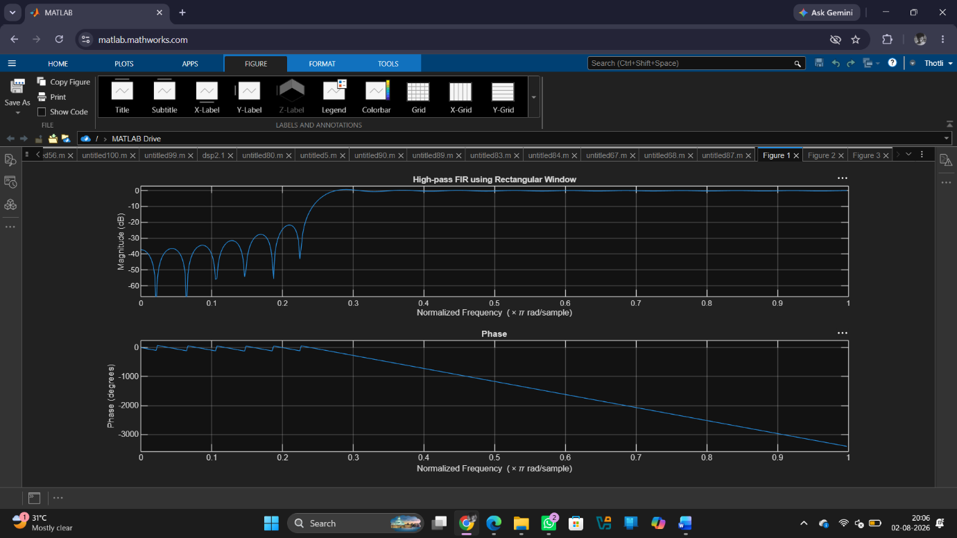

Fig 2
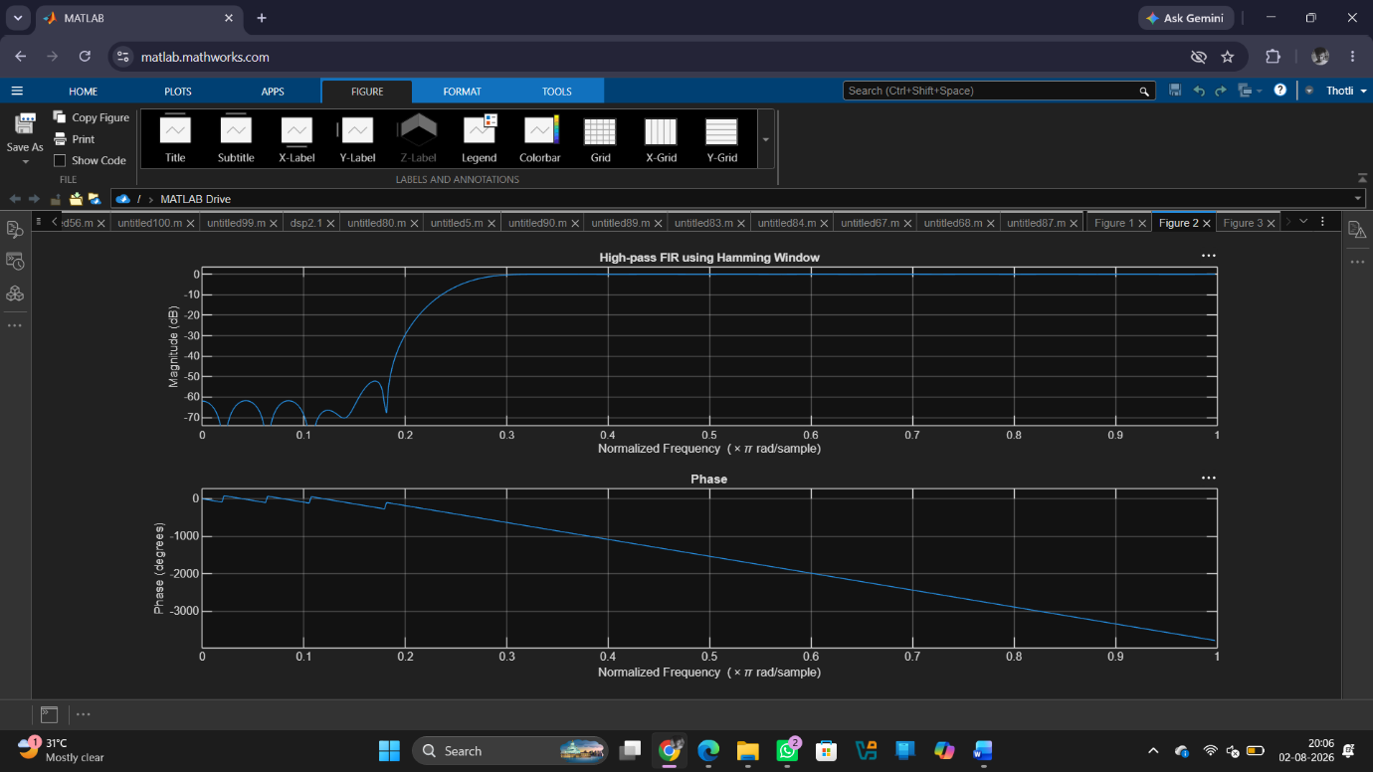

Fig 3
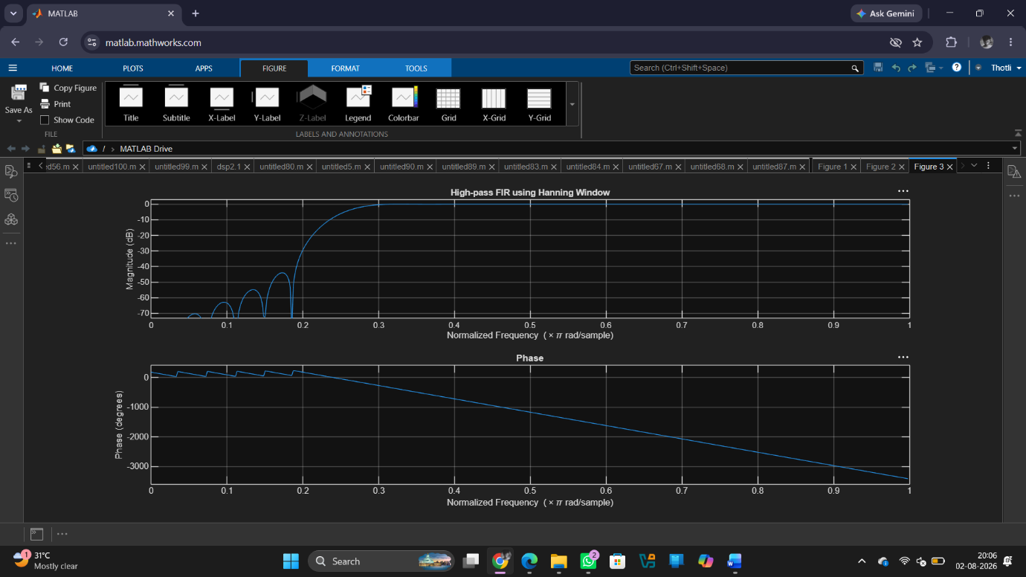

Result:
1. The FIR High-Pass Filter was successfully designed using the Rectangular Window technique for the specified cutoff frequency, sampling frequency, and filter order.
2. The FIR filter coefficients were successfully generated using MATLAB and the designed filter was implemented.
3. The magnitude response and phase response of the designed FIR High-Pass Filter were obtained and analysed.
4.The magnitude response showed attenuation of low-frequency components and passage of high-frequency components, confirming the desired high-pass filtering behaviour.
5.The phase response exhibited the expected linear-phase characteristics of an FIR filter.

